Locked Out of the Labor Force: The Rise of Criminalization and the Fall in Work

Ryan Larson, Sarah Shannon, Aaron Sojourner & Chris Uggen

**Research question**: how much has the rise in the share of Americans living in the community with a criminal record contributed to the fall in the labor force participation rate and employment share?

**Contributions:**

* Focuses on the connection between two first-order economic and policy issues
  + Falling labor force participation rates
  + Rise in share of adults with a felony record
* Leverages first state-year estimates of the share of adult population with a felony record (Shannon et al 2017).

**Motivation:** An increasing share of Americans are living in the community with a felony record having paid their debt to society. Between 1980 and 2010, the share of American adults living in the community with a felony record rose from 2.4 percent to 6.2 percent (Shannon et al 2017). Younger people are more likely to be arrested and convicted meaning that the rise among prime-age adults is likely much larger than this, although more age-specific estimates are not available.

Falling prime-age male labor force participation presents a troubling challenge for the American economy. The fall has been particularly steep among men with the least education (CEA 2016). Among those with a high school degree or less, participation fell by about 8 percentage points between 1980 and 2010, consistent with a trend extending back to the 1960s. Since 2003, prime-age female labor force participation has also fallen.

Looney (2018) finds a large negative relationship between individual past incarceration and employment. Abraham and Kearney (2018) point out that because the share of formerly incarcerated is small, this channel cannot explain much of the overall decline in employment probability.

We focus on the role of having a felony record rather than being formerly incarcerated. This group is about three times larger (Shannon et al 2017). CEA (2016): “nearly 3,000 mandatory license exclusions for individuals with a felony record (American Bar Association 2016). In addition, evidence shows that, even in the absence of legal restrictions, employers are less likely to hire someone with a criminal record (Holzer 2007)… (Holzer, Offner, and Sorensen 2005; Holzer 2007; Pager 2003).

Prior evidence constrained by lack of annual data available below the national level. Our main contribution derives from studying the relationship between new state-year estimates of the share of adults in the community with a felony record, built from the estimation machinery of Shannon et al 2017, to Current Population Survey state-year measures of engagement in the labor market. This enables state-level generalized difference-in-difference models to estimate the association between changes in the share of state populations with felony record to changes in labor market engagement over the period 1980 to 2010.

Eberstadt (2016) used an early version of the Shannon et al data for 1980, 1990, 2000, and 2010 to make a scatterplot of the share of adults with a felony record against the share of prime-age men not in the labor force across the 50 states in the 4 different years. This is a pooled cross-section. He does not study changes within state nor does he have annual estimates for the intervening years, nor does he do any kind of regression analysis.

**Data and design**

*Population and sample:* we focus on the national population of civilian, non-institutionalized, prime-age (25-54 years old) adults who do not have a bachelors degree as sampled in the Current Population Survey from 1980 to 2010. This excludes incarcerated individuals.

*Outcomes (Yst):* our primary outcome is the population’s rate of non-employment in each state and year. We focus on the not-employed rate instead of its more-conventional complement, the employment-to-population ratio, simply for the expositional convenience of having an expected positive relationship between the dependent and independent variables.

A supplementary outcome is the population’s idleness rate, which deducts the share of the population in school or in unemployment (actively searching for work).

A third outcome, available only from year TBA forward, is the rate of people not in the labor force reporting that this is primarily because they can’t find work.

*Predictor (Fst):* the share of the state-year adult population living in the community with a felony record having paid their debt to society. This excludes incarcerated individuals or those on probation. Shannon et al 2017 pioneered creation of these estimates and reported state-level decennial estimates for 1980 through 2010. Noone has had such estimates before. State-representative surveys do not ask these questions. Shannon et al harness available aggregate data on flows into and out of conviction, imprisonment, probation, and death these of the stocks of people with a felony record based on. We use the underlying annual state-level estimates.

The estimates are for the share of adults (age 18+). More-refined estimates by age or education are not available. Estimates by gender and race are available but noisier.

Because the big rise in convictions happened in the mid-1980s and primarily among the young, focusing on outcomes among prime-age adults has the dual benefits of focusing on the group where (1) most of the change in felony-record share has occurred and (2) the fall in work is most troubling.

*Model:* we use a generalized difference-in-differences design that relates changes in states’ not-employed rate (*Yst*) over time to their change in share of adults in the community with a felony record (*Fst*). We include state fixed effects (γs) to capture average stable, unobserved influences on each state’s outcome and year fixed effects (γt) to capture average unobserved influences across states within each year.

The identifying assumption is that changes in unobserved influences within state are mean independent of changes in *Fst.* In order to enhance the credibility of this condition more credible, we will also condition on various observable, time-varying state-year characteristics (*Xst*).

*Control variables/potential confounders (Xst):*

*Tables*

Table 1: summary stats

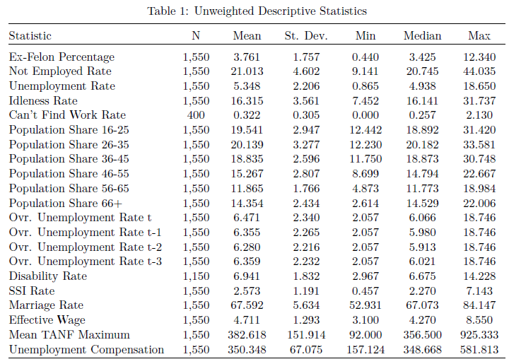

Table 2: not-employed rate regression for prime age adults

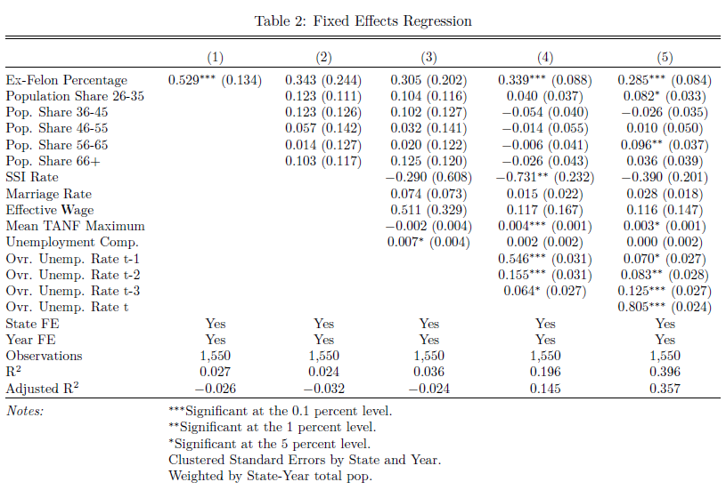

Table 3: Last specification from Table 2 but columns change the outcome to idleness rate, unemployment rate (omitting concurrent), and can’t find work rate

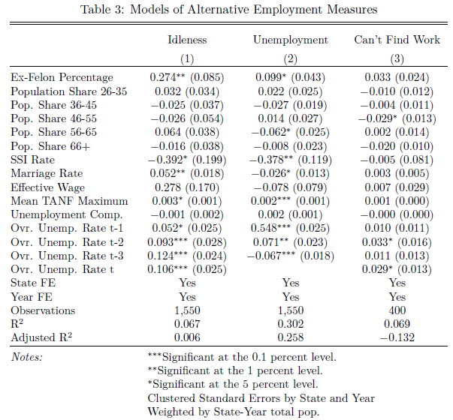

Table 4: not-employed rate, final specification columns across alternative subpopulations: PA men, PA women, black PA. white PA, working age all,

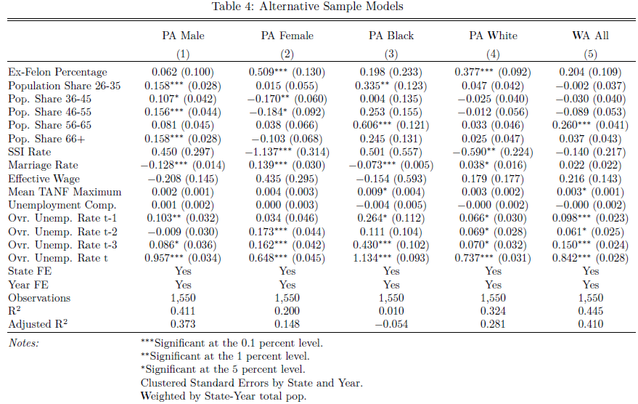

*Figures*

First-difference scatterplot with best-fit line pooling across all states and years

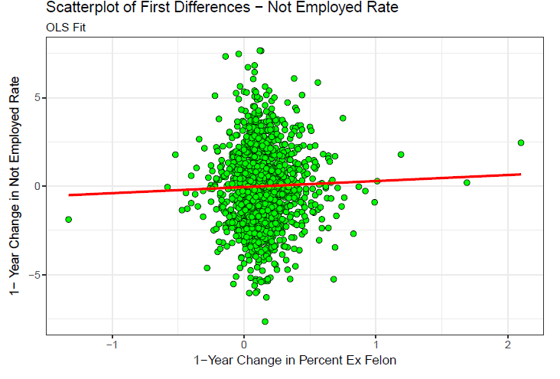

Estimated effects over time: plot point estimate and confidence interval for Table 2, final specification but estimated on rolling 10-year (5-year?) subsamples plotted with year on the horizontal and estimates on vertical.

